Growing shade   
Interactive Tool

User Guide

White Bar Art

The Council’s mission is to foster  
efficient and economic growth for   
a prosperous metropolitan region

**Metropolitan Council Members**

|  |  |
| --- | --- |
| Charlie Zelle Chair Judy Johnson District 1 Reva Chamblis District 2 Christopher Ferguson District 3 Deb Barber District 4 Molly Cummings District 5 Lynnea Atlas-Ingebretson District 6 Robert Lilligren District 7 Abdirahman Muse District 8 | Raymond Zeran District 9 Peter Lindstrom District 10 Susan Vento District 11 Francisco J. Gonzalez District 12 Chai Lee District 13 Kris Fredson District 14 Phillip Sterner District 15 Wendy Wulff District 16 |

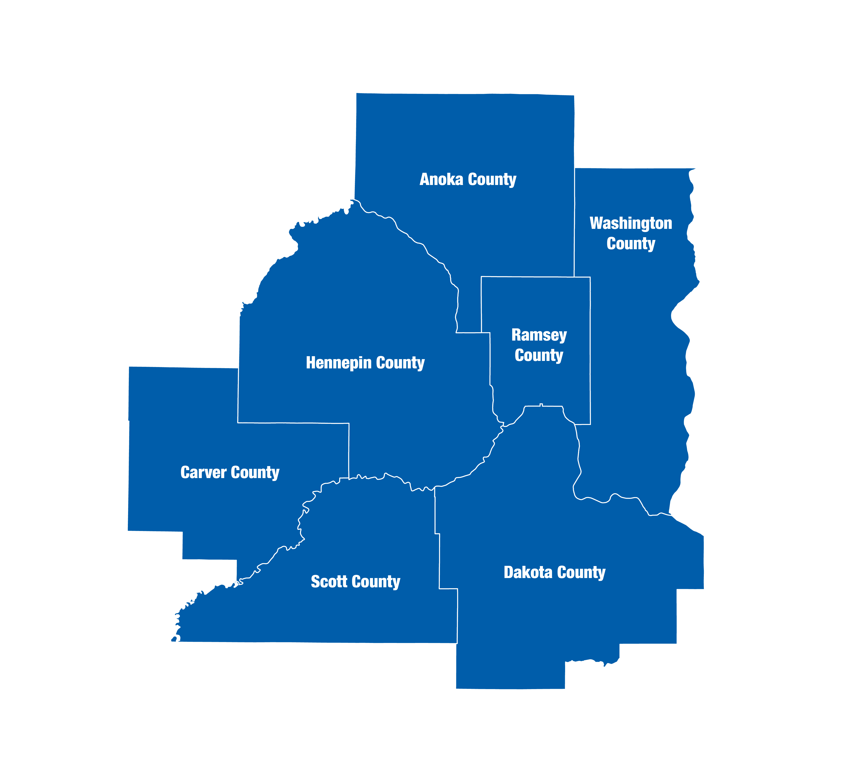  
The Metropolitan Council is the regional planning organization   
for the seven-county Twin Cities area. The Council operates the regional bus and rail system, collects and treats wastewater, coordinates regional water resources, plans and helps fund regional parks, and administers federal funds that provide housing opportunities for low- and moderate-income individuals and families. The 17-member Council board is appointed by and serves at the pleasure of the governor.

On request, this publication will be made available in alternative formats to people with disabilities. Call Metropolitan Council information at 651-602-1140 or TTY 651-291-0904.

# Introduction

## What the Growing Shade Interactive tool does

The Growing Shade project recognizes that trees provide critical ecosystem services and are important components of both natural and built environments. With a desire to create healthy places for people to live (mitigate heat islands and/or reduce home cooling costs, reduce localized flooding risk, improve mental health, etc.) and a resilient future (carbon sequestration, biodiversity, etc.), building or enhancing tree canopy cover is an actionable step.

This interactive provides stories and data to identify areas where an enhanced tree canopy could have a disproportionately positive benefit for people and environment. Stories provide a narrative to contextualize the importance of this work within our region. Users can customize data variables to reflect specific priorities towards identifying tree planting opportunities. Data is also provided towards helping stakeholders evaluate other considerations involved with tree plantings, such as cost-benefit analysis and species considerations.

## What the Growing Shade Interactive tool cannot do

Users can create valuable, data-driven analyses through this tool. Our experience and research tells us that data cannot substitute for engagement with prioritized stakeholders to understand community-specific concerns or opportunities. The on-the-ground knowledge of residents and the expertise of practitioners are valuable sources of information necessary to enhance and refine the shared understanding of this data.

# User Interface

## “Home” tab

On the home page, find a general overview about what this tool does, and ways in which you might find this tool useful. To begin using the tool, notice the tabs on the top of the screen. This document goes through each tab in detail.

Click the tabs on top of the screen to begin using the tool

## “Narrative” tab

This tab shares stories about the intersections of Minnesotans and the tree canopy. People whose work and passions impact the tree canopy. And people who are impacted by the tree canopy.

Scroll down to explore these stories.

## “Use the tool” tab

This tab allows users to explore Census data at the intersection of trees and people in detail. This page has three main components: 1) a place for users to customize the analyses, 2) a map of tree canopy prioritization and existing canopy cover, 3) a user-generated report.

**\*\*NOTE: You MUST select the NAME of a city or neighborhood from the dropdown to have the whole functionality of the tool\*\***

Map

Report

Customizations

This is a bit about how you actually start using the tool. What to click on, etc.

Select a preset (or “custom”) to show a tree prioritization layer. Click the question mark for more information.

Pick an area from the dropdown menu to generate a report. Picking an area will also make the map at right show the tree canopy within the area.

Click for information about using this tool.

Toggle map layers “on” or “off”.

Use the buttons or scroll to zoom in and out.

This is old…..

To customize the map, select a “preset” on the left of the screen to create a tree canopy enhancement or maintenance priority layer. Selecting “custom” activates several drop down menus from which inputs can be selected. Click on a variable to turn in “on” or “off” – a “check mark” indicates that the input is being used to calculate priority scores.

More information about presets.

Click to hide this menu.

A checkmark indicates this variable is being used to calculate priority scores. Click the variable to turn on or off.

Click the question mark for more information about the presets and priority scoring.

You can also drag this box around the map, or click on the “Customizations” box on the top to “hide” this menu.

Pan around the map and zoom in. Click on any area to get more information about the selected geography. Clicking on an area also activates the tree layer, which shows where current tree canopy is.

Toggle layers on or off. Please note that “Priority score” MUST be “on” to get more information about any area.

Click on an area in the map for more information. A popup tells you some information, and a layer showing the existing tree canopy is created (in green). The blue box shows the outline of the area which is selected.

Toggle layers on and off using the layer menu and the bottom right of the screen.

If you wish to use a map in a report or for other purposes, we recommend taking a screenshot of your preferred view.

## “Methods” tab

This tab provides information about how the data was collected and processed.

­390 Robert Street North  
Saint Paul, MN 55101-1805

651.602.1000  
TTY 651.291.0904  
[public.info@metc.state.mn.us](mailto:public.info@metc.state.mn.us)  
metrocouncil.org

Follow us on:  
twitter.com/metcouncilnews  
facebook.com/MetropolitanCouncil  
youtube.com/MetropolitanCouncil

